
Business Question and Visualization Report

Date | 29 July 2026
Team ID | Rithika C
Project Name | India's Agricultural Crop Production Analysis (1997–2021)
Maximum Marks | 5 Marks

Business Questions and Visualizations
Q1. What are the overall agricultural production KPIs for India?
Visualization:
KPI Cards displaying Total Agricultural Production, Total Cultivated Area, Number of States/UTs, Number of Crops, and Number of Seasons.

Insight Provided:
Provides a quick overview of the agricultural dataset by summarizing the key performance indicators, enabling users to understand the overall scale and coverage of agricultural production in India.
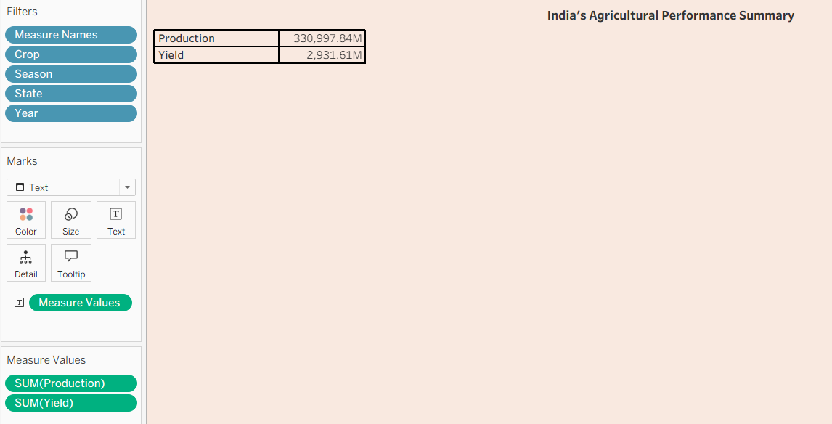

Q2. How has India's total agricultural production changed from 1997 to 2021?
Visualization:
Line Chart representing year-wise total agricultural production.

Insight Provided:
Highlights the production trend over time, allowing users to identify periods of growth, decline, and fluctuations in agricultural production across the study period.
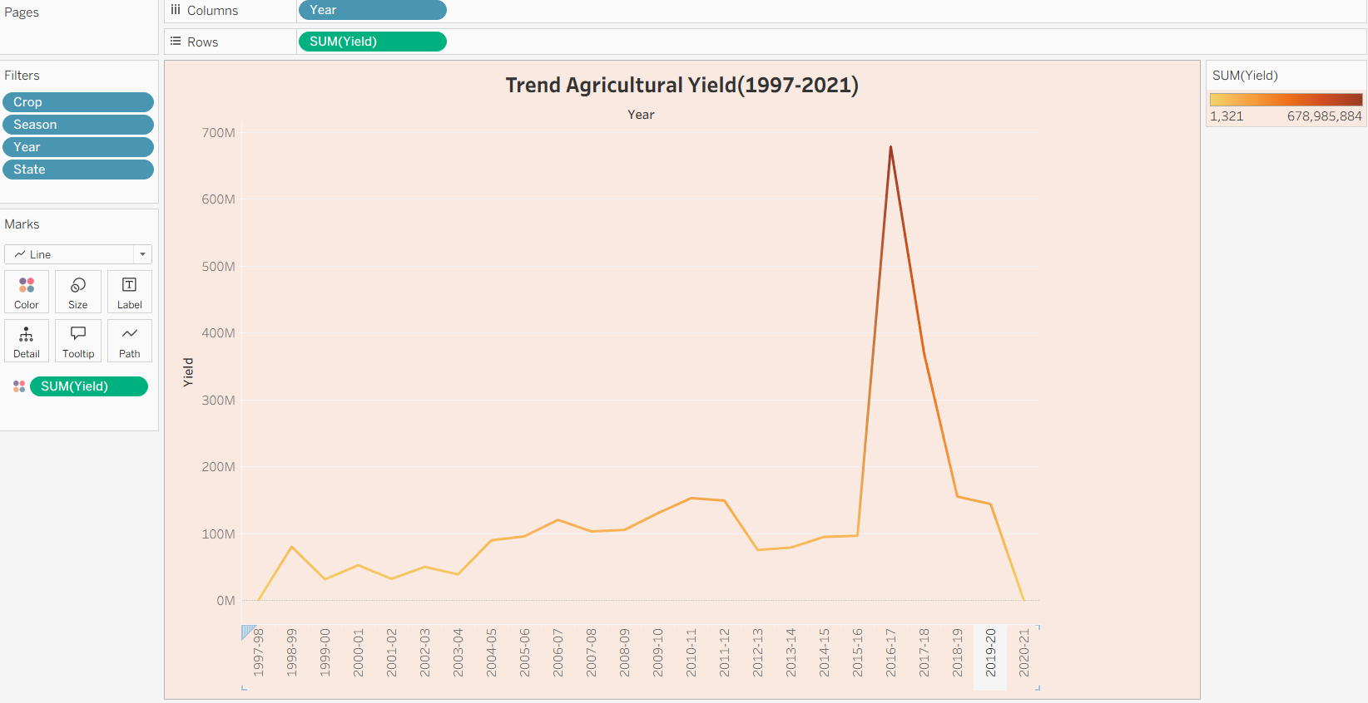

Q3. How is agricultural production distributed across different states in India?
Visualization:
Filled Map (Map Chart) displaying state-wise agricultural production using color intensity.

Insight Provided:
Illustrates the geographical distribution of agricultural production, helping users identify high-producing and low-producing states across India.

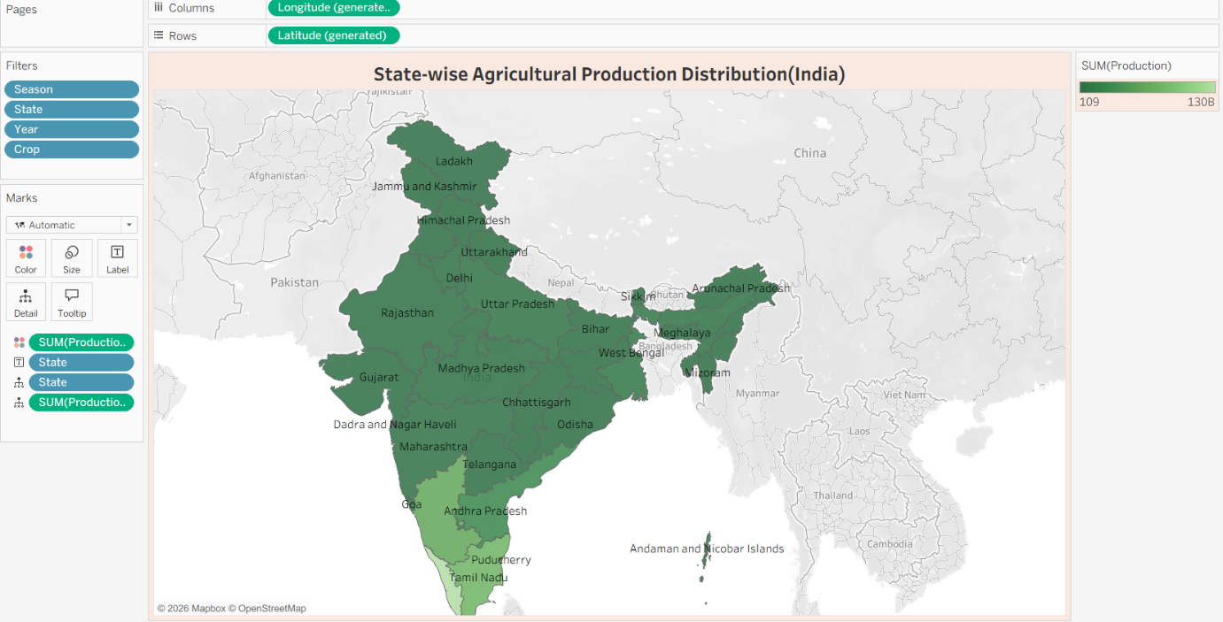

Q4. Which crops occupy the largest cultivated area in India?
Visualization:
Horizontal Bar Chart showing cultivated area by crop.
Insight Provided:
Compares the cultivated area of different crops and identifies the crops that utilize the largest agricultural land, supporting crop pattern analysis.
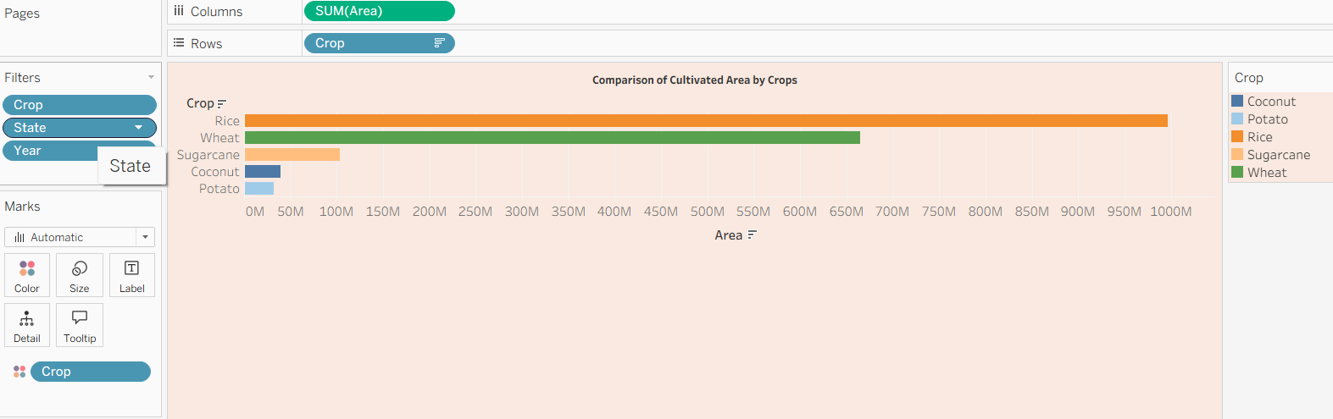

Q5. Which states have the largest cultivated agricultural area?
Visualization:
Bar Chart displaying state-wise cultivated area.

Insight Provided:
Enables comparison of agricultural land utilization across different states and highlights regions with extensive cultivation activities.

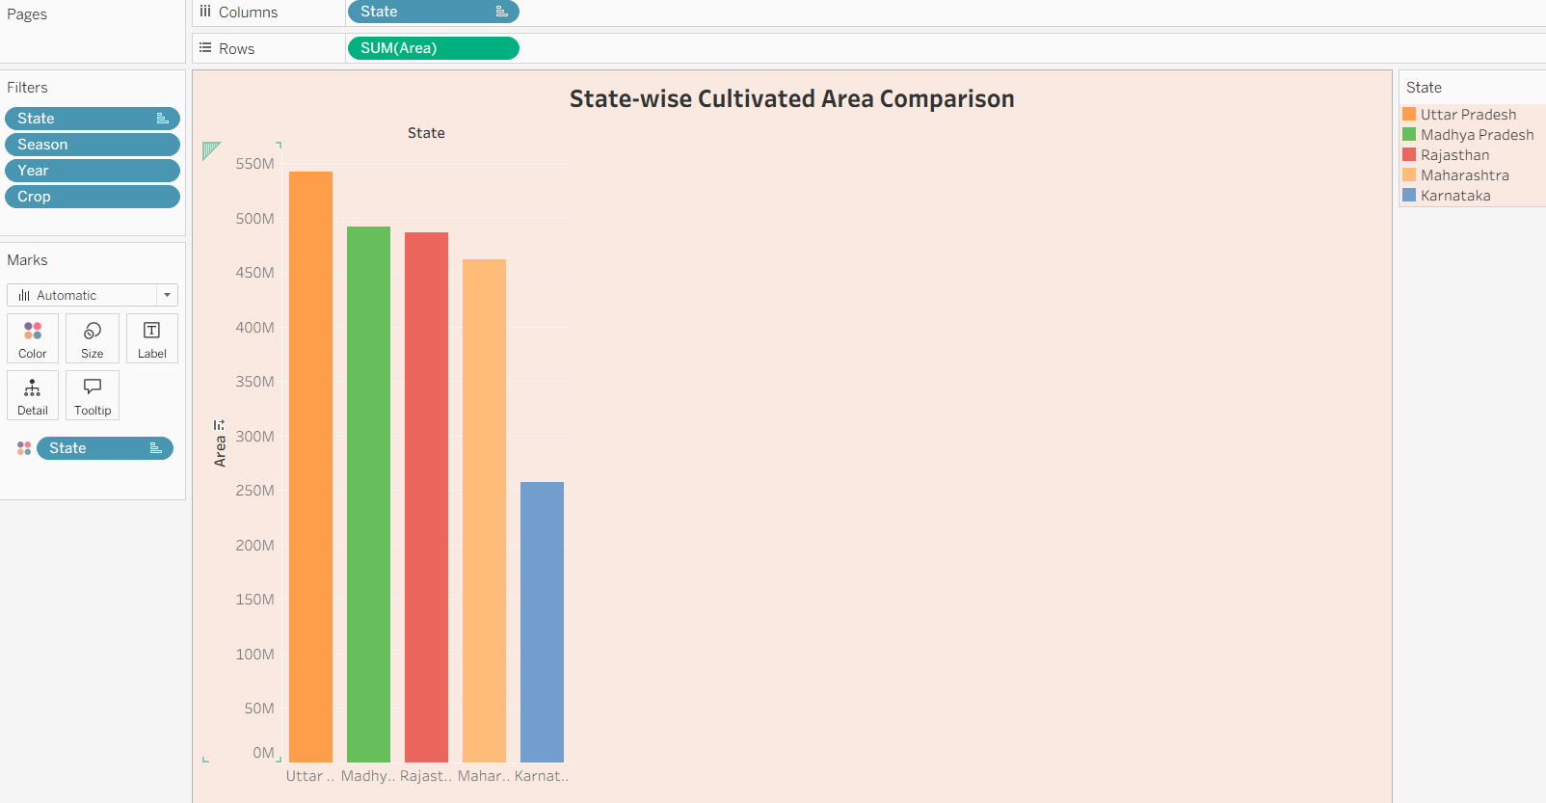

Q6. Which states contribute the highest agricultural production?
Visualization:
Bar Chart representing total agricultural production by state.

Insight Provided:
Ranks states based on total agricultural production, helping users identify the leading agricultural producers and compare regional productivity.
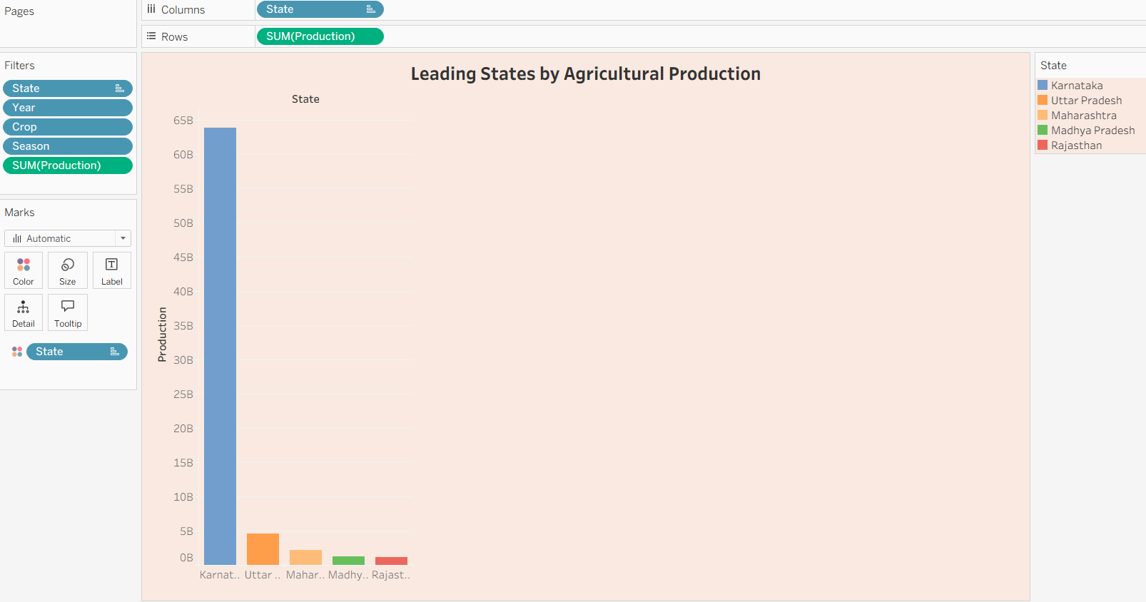

Q7. How has total agricultural production varied by year?
Visualization:
Vertical Bar Chart showing year-wise total agricultural production.

Insight Provided:
Provides a year-by-year comparison of agricultural production, making it easier to observe annual variations and production patterns throughout the study period.

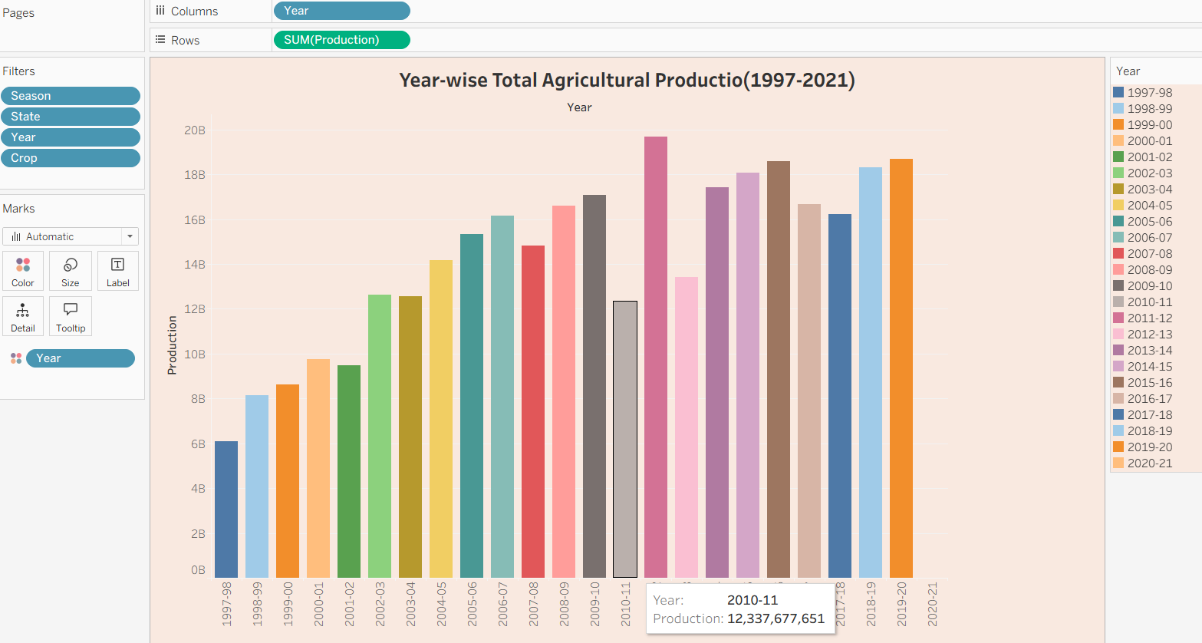

Q8. How is agricultural production distributed by production unit type?
Visualization:
Donut Chart illustrating the distribution of production by unit type.
Insight Provided:
Shows the percentage contribution of each production unit type, enabling users to understand the composition of production measurements within the dataset.

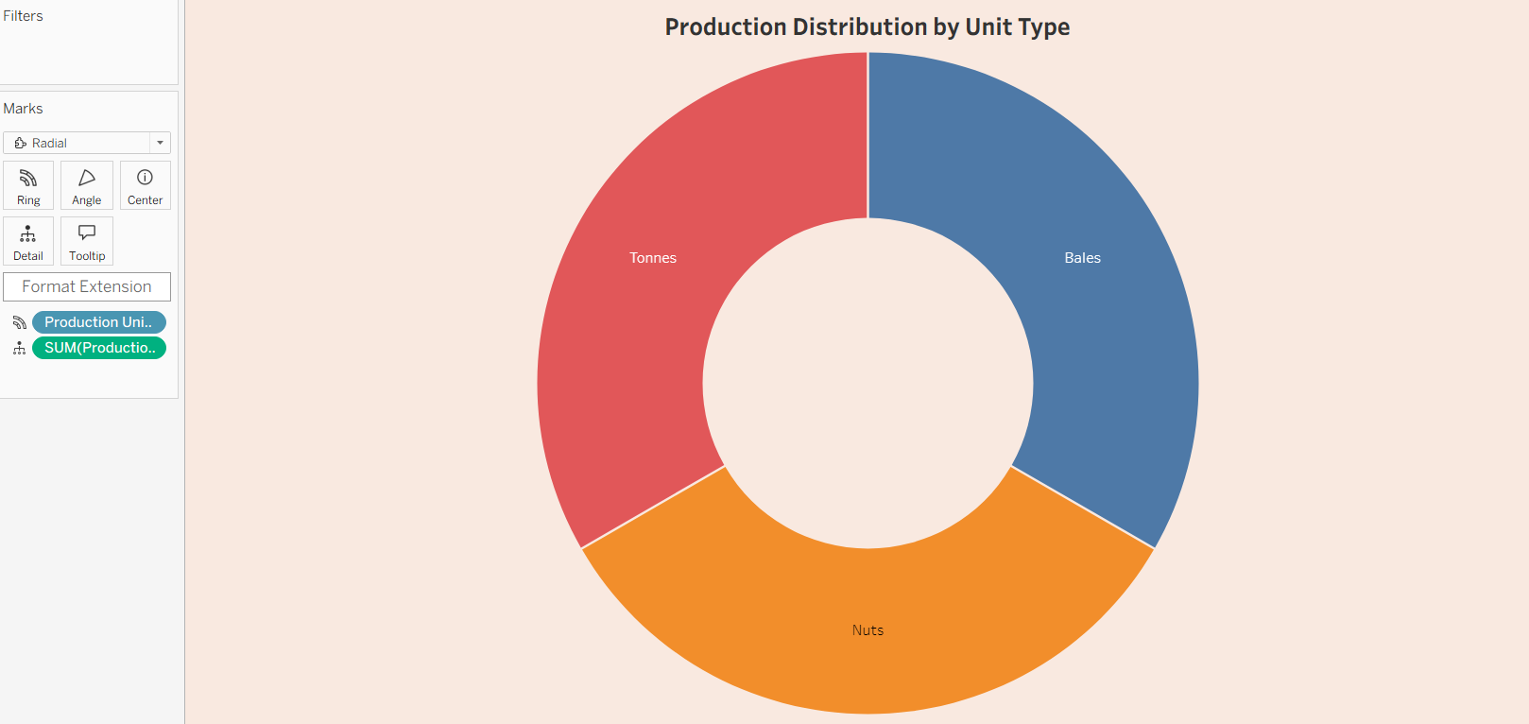

Q9. What percentage of agricultural production is contributed by each season?
Visualization:
Pie Chart representing season-wise agricultural production share.

Insight Provided:
Displays the contribution of each agricultural season to total production, helping users understand seasonal production patterns and identify the most productive seasons.

